Tuesday, April 21st | Activity
Math  Volume will be taught through Khan Academy | - Login to Khan Academy  - Complete Volume activities (there are 5 total)  Khan Academy items are Due Friday
ELA | - Complete BOTH planning sheets (both sheets are on the Weebly page)  - The Plot “mountain”  - The Comic Strip planning sheet  Examples from our lesson are on the Weebly page
Science | Keep working on your PSA or infographic if you haven’t finished.
Reading  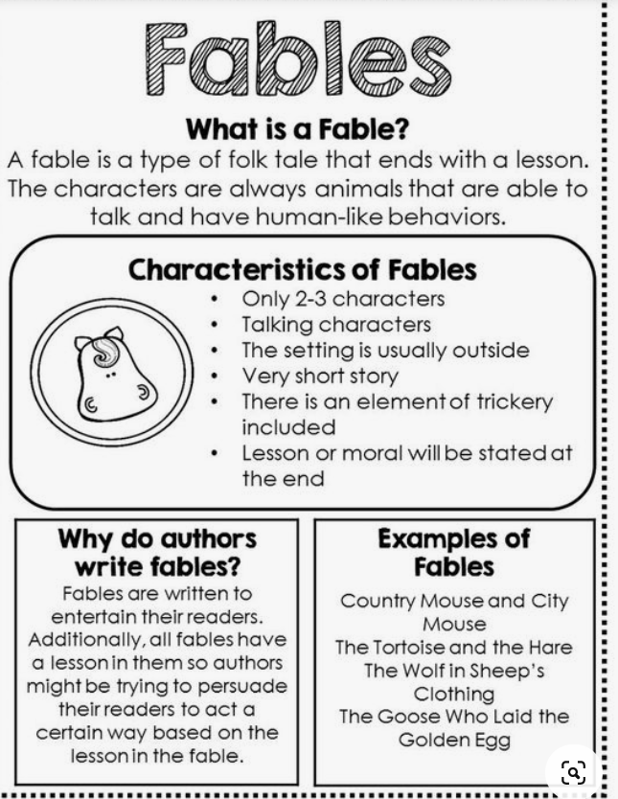 | - Our lesson will actually be on Wednesday at 10am through TEAMS. Here is what you need to do before the meeting:  - Watch “Theme” video on Brain Pop Jr.  - Read the TWO fables  - “The Tortoise and the Baboon”  - “How the Coyote Stole Fire”  - You need to have the compare and contrast organizer preprinted and ready to go. We will fill it out together during our TEAMS meeting.

