Tuesday, April 14th | Activity
Math  Today we are working on figuring out what is a reasonable measure of mass for an object. I selected the following LearnZillion video, this explains it better than I think I could have.  https://learnzillion.com/lesson_plans/7216-estimate-the-mass-of-an-object/lesson  I will be available through TEAMS for students or parents with any questions about the assignment from 11am-11:30am. Link will be sent through Dojo. | - Work on the problems on the following page.  - Zearn  - Practice multiplication facts
ELA | - Login to Grammaropolis and complete your adjectives badge.  Please let me know if I had not sent you your noun and verbs badge yet. If you successfully completed the quizzes, I sent it to you through Dojo.
Science (All students in my class)  Continue with this lesson if you are not finished.  Mystery Science is free, you DO NOT need a  login. | Mystery Science Lesson- “What’s the Best Way to Get Rid of Mosquitoes?”  https://mysteryscience.com/animals/mystery-7/environmental-change-engineering/266?code=OTY3Mjky&t=student
Reading  Continue with this lesson if you are not finished.  Have students go to www.readworks.org/student  Students enter class code 7TAB3V  Students find their names | You have 1 Readworks passage.  Read Theory

Math Assignment
Name Date
- Match each object with its approximate weight.

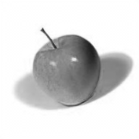
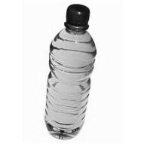
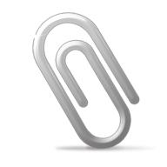
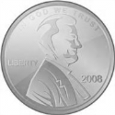
100 grams
10 grams
1 gram
1 kilogram

- Alicia and Jeremy weigh a cell phone on a digital scale. They write down 113 but forget to record the unit. Which unit of measurement is correct, grams or kilograms? How do you know?

