Infographic Task

Now that we’ve had the opportunity to participate in the “Human Impact” lesson in Nearpod, you will create an infographic about some of the issues we encountered.
Topics to choose from:
- What is a carbon footprint?
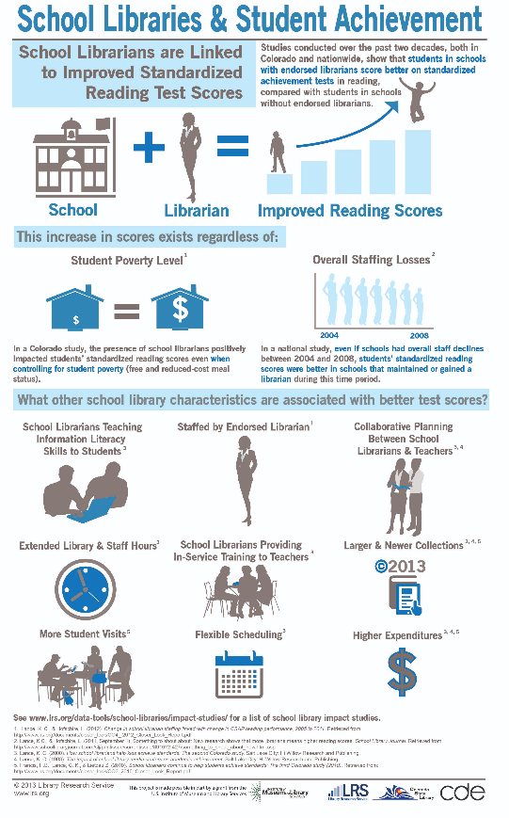
- What is an ecological footprint?
- The issue with landfills becoming full.
- Living a zero-waste lifestyle.

Examples of infographics
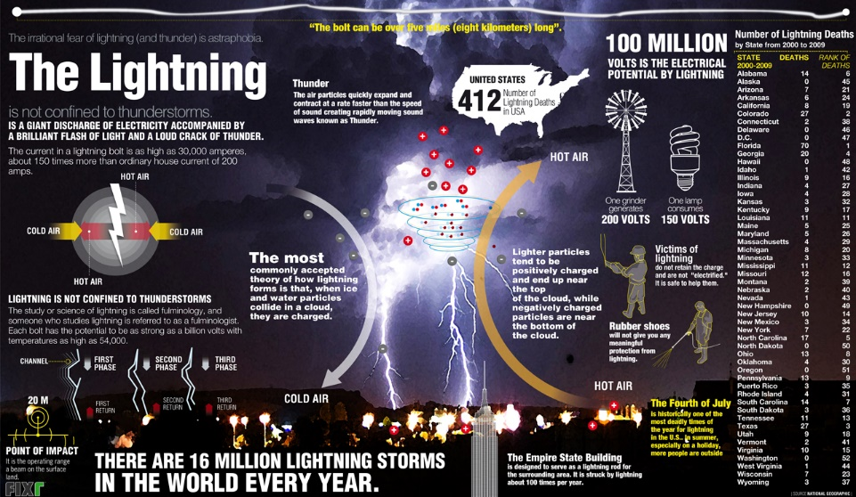
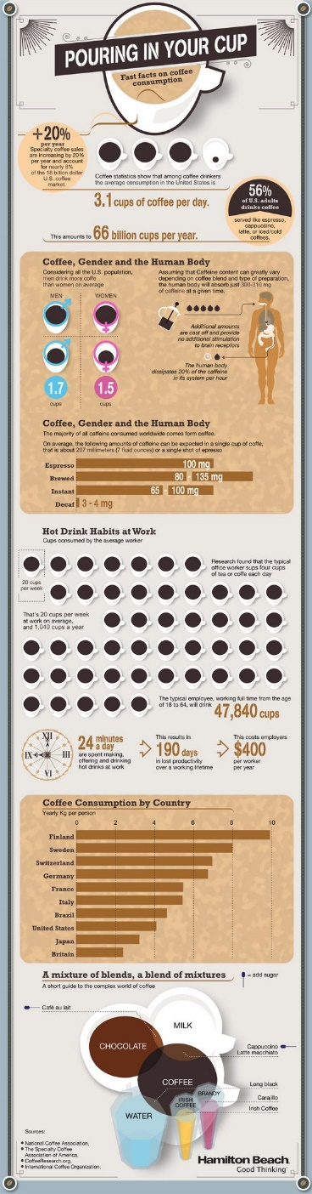

Criteria
- There should be a balance of written information and graphics.
- Main points should be clear to viewer
- Back up points with statistics of facts- you can revisit the Nearpod for information if needed.
- Please see rubric (next page) for additional information.

Infographic Rubric

Student Name: ___________________________________________________________________

Topic: _______________________

 | Category |  |  |  | 4 |  | 3.25 |  | 3 |  | 2
 |  |  |  |  | All statistics are accurate (minimum of 5) |  | Some statistics may be misleading or unclear. |  | Some statistics cannot be verified. |  | Statistics were not included.
 | 1. | Research
 |  |  |  |  | All graphs and charts used are appropriate for the data displayed and includes a variety of types of charts and graphs. |  | All graphs and charts used are appropriate for the data displayed but are limited to one or two types of graphs or charts. |  | Some graphs or charts may not be appropriate for the data displayed or maybe inaccurate. |  | No graphs or charts included OR none of the graphs or charts are appropriate/accurate for the data displayed.
 | 2. | Graphs and Charts
 |  |  |  |  | Design elements of infographic contribute to clear communication of topic. |  | Design elements of infographic do not interfere with communication of topic. |  | Important design elements, such as titles, may be missing. |  | Infographic is incomplete and missing many important design elements.
 | 3. | Infographic Design
 |  |  |  |  | Additional elements, such as pictures or maps, are incorporated to enhance the infographic. |  | Additional elements are used, but do not enhance the infographic. |  | No additional elements are used. |  | Additional elements are included that are not relevant to the topic of the infographic.
 | 4. | Creativity

Total Score ___________/16

